***Dt : 19/10/2022***

***Execution flow of above program:***

***ClassFiles:***

***SubClass1.class***

***DemoInnerClass2.class(MainClass)***

***SubClass1$SubClass2.class***

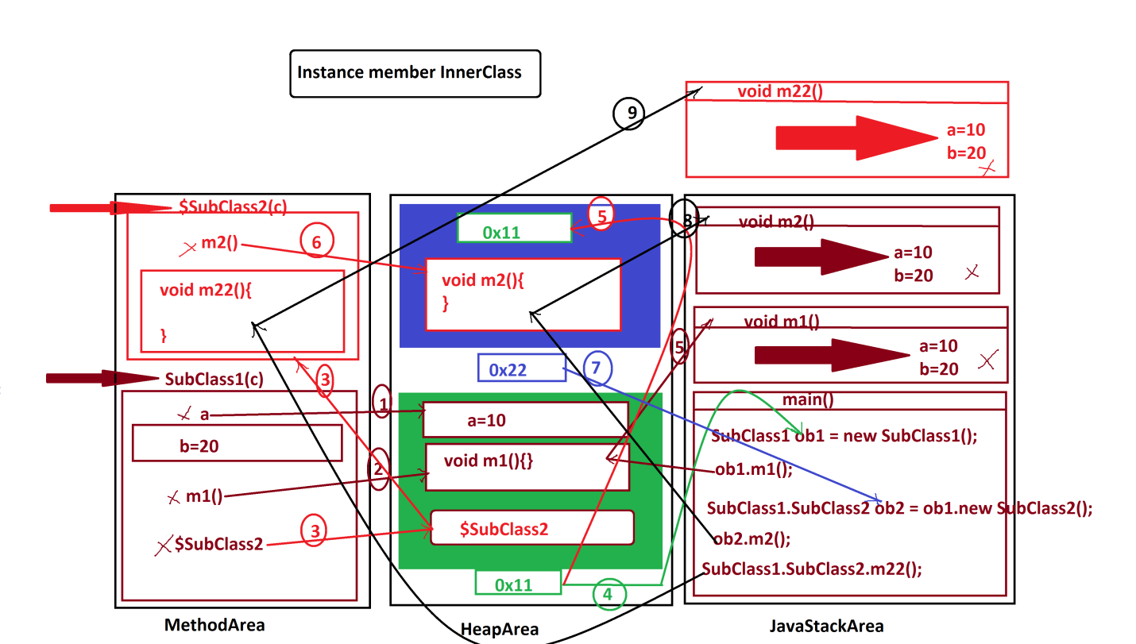

***-------------------------------------------------------------------***

***Note:***

***=>In Instance member InnerClasses the InnerClass object will hold the***

***reference of OuterClass object,in this process the methods of InnerClass***

***object can access the members of OuterClass object.***

***=============================================================***

***2.Local member InnerClasses:***

***=>The NonStatic member InnerClasses which are declared inside the method***

***of OuterClass are known as Local InnerClasses.***

***=>The Local InnerClasses can be declared in 'static and NonStatic methods***

***of OuterClass'.***

***=>The Local InnerClass in Instance methods will have behaviour like***

***"Instance member InnerClass" and the Local InnerClass in Static methods will***

***have behaviour like "Static member InnerClasses.***

***Coding Rule:***

***=>Local Member InnerClass objects are created inside the methods.***

***Ex:***

***SubClass1.java***

***package test;***

***public class SubClass1 {***

***public void m1(int x) {***

***class SubClass2{***

***public void m2(int x) {***

***System.out.println("===Local InnerClass m2(x)====");***

***System.out.println("The value x:"+x);***

***}***

***}//Instance member InnerClass***

***SubClass2 ob2 = new SubClass2();//Local InnerClass object***

***ob2.m2(x);***

***}//OuterClass Instance method***

***public static void m11(int y) {***

***class SubClass22{***

***public void m22(int y) {***

***System.out.println("===Local InnerClass m22(y)====");***

***System.out.println("The value y:"+y);***

***}***

***}//Static member InnerClass***

***SubClass22 ob22 = new SubClass22();//Local InnerClass object***

***ob22.m22(y);***

***}//OuterClass Static method***

***}//OuterClass***

***DemoInnerClass3.java(MainClass)***

***package maccess;***

***import test.*;***

***public class DemoInnerClass3 {***

***public static void main(String[] args) {***

***SubClass1 ob1 = new SubClass1();//OuterClass object***

***ob1.m1(121);//OuterClass Instance method call***

***SubClass1.m11(123);//OuterClass Static method call***

***}***

***}***

***o/p:***

***===Local InnerClass m2(x)====***

***The value x:121***

***===Local InnerClass m22(y)====***

***The value y:123***

***----------------------------------------------------------------***

***ClassFiles:***

***SubClass1.class***

***DemoInnerClass3.class(MainClass)***

***SubClass1$1SubClass2.class***

***SubClass1$1SubClass22.class***

***==============================================================***

***\*imp***

***(b)Anonymous InnerClasses:***

***=>The process of declaring InnerClasses without name are known as***

***"Anonymous InnerClasses"***

***=>These Anonymous InnerClasses are categorized into two types:***

***1.Anonymous InnerClass as Class extention***

***2.Anonymous InnerClass as Implementation class***

***1.Anonymous InnerClass as Class extention:***

***=>The process of declaring the CClass without name is known as***

***"Anonymous InnerClass as Class Extention".***

***syntax:***

***class PClass***

***{***

***//PClass_body***

***}***

***PClass ob = new PClass()***

***{***

***//CClass_body***

***};***

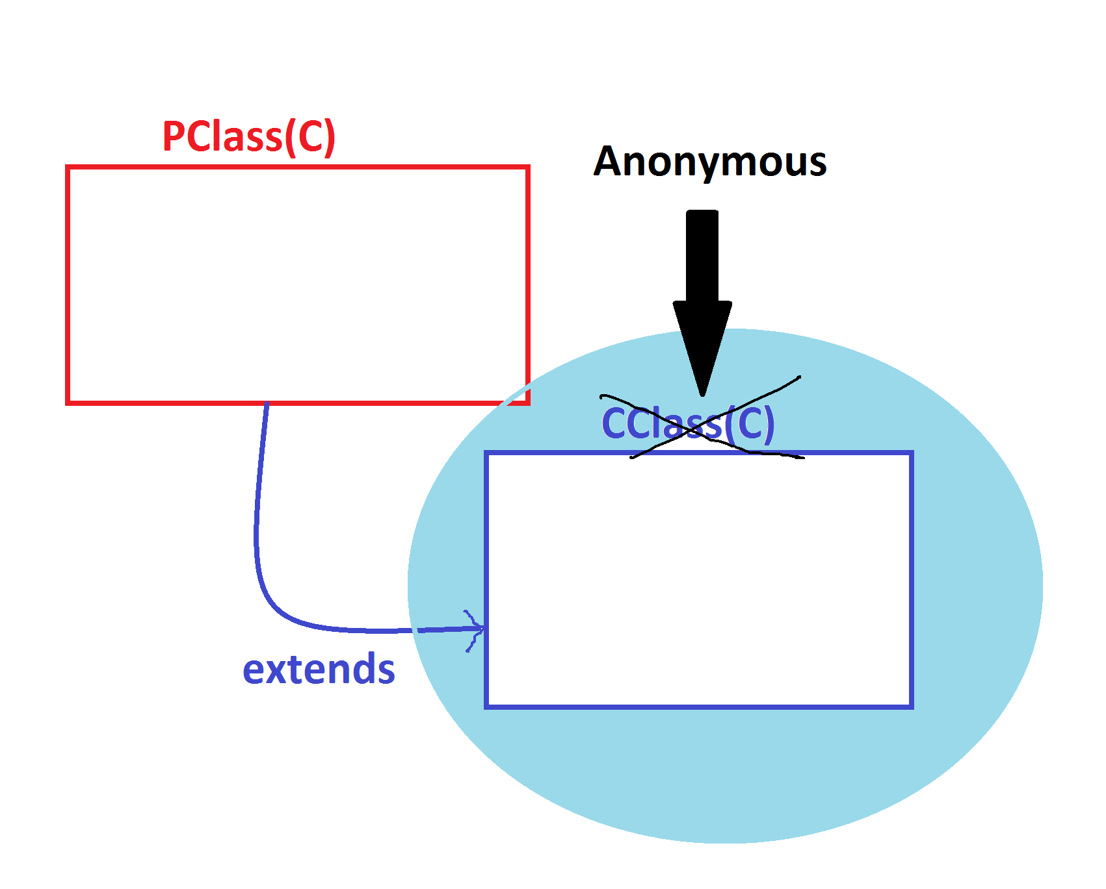

***2.Anonymous InnerClass as Implementation class:***

***=>The process of declaring implementation class without name is known***

***as "Anonymous InnerClass as implementation class"***

***syntax:***

***interface ITest***

***{***

***//Interface_body***

***}***

***ITest ob = new ITest()***

***{***

***//ImplClass_body***

***};***



